User uses remote in order to switch on/off TV, increase/decrease the volume, change the channel etc. without bothering how internally it works – Abstraction.

What happens internally?
TV remote controls have an LED light in them which flashes really quickly to emit a message which is then picked up by the TV. A TV remote uses a type of light called infrared (or IR for short). The remote control has an LED light in it which flashes really quickly to emit a message which is then picked up by the TV. The remote is called the transmitter, and the TV is called the receiver.

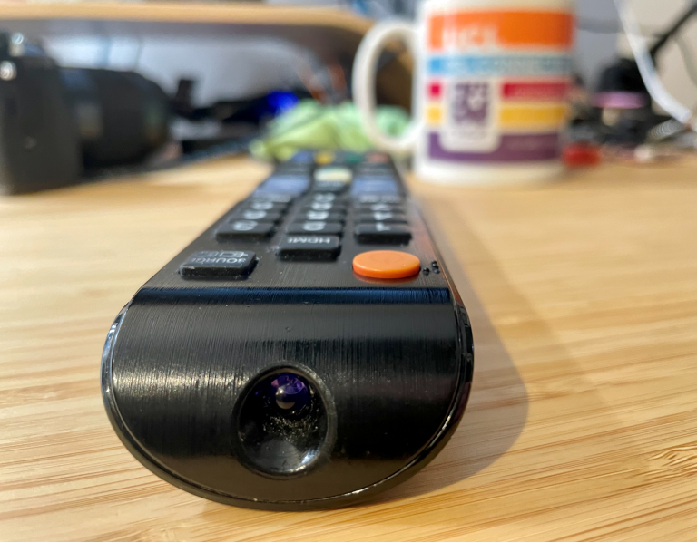

our remote control is emitting a signal in a special sequence of 0’s and 1’s. It does this by turning the light on and off. For example, the code for “turn up the volume” in the example below is a series of light flashes for volume up followed by a special code for the type of TV being controlled. The time between the flashes dictates if a 0 or 1 is being sent.

